A kick, a hiccup, just something to let you know that there is someone else, someone completely other than yourself, in your body. It’s hard to explain how strange that feels. The quickening, they call it.

Mary was in love. Not in the sense of being in love with anyone in particular. Just in love. And love told her to go quickly and see her cousin Elizabeth. Love is closely linked to intuition.

One afternoon, many years ago, I was quickly introduced to, and then left alone with, a friend of a friend, a woman who was quite a bit older than I was at the time. I remember standing there in her house and it might have been awkward but it wasn’t. I think she showed me around. It was tidy. And I’m not sure we really said anything at all. We just laughed. It seemed like we laughed together for a long time. And that was it; we said goodbye and I went home. I didn’t know what to make of it. I still don’t. But I think it was an instance of love.

Love was in Mary’s body and she, in turn, was in love.

(Like I said to the children earlier,) Love is a little bit like a Matryoshka, a Russian doll. It occupies time and space but not in the conventional sense. It encapsulates both and extends beyond either. Microcosmos, macrocosmos. Love is all of it.

Two of my nieces had children at the same time as I had Oscar and Lila. It offered me the opportunity to connect with them in a different way, and I still cherish the times we spend talking about our kids, encouraging–and commiserating with–each other as parents. It has collapsed time in a way, and changed the nature of our relationship to something more like peers. I’m guessing that Mary and Elizabeth had that kind of relationship.

Time collapses when you carry a child. But we don’t need to be with child to recognize and experience that reality. Each of us carries the past and the future around us and within us.

Once, when I was gazing at one of my children as a newborn, and time was playing its game of stretching and compressing as it does when you’re sitting alone with a baby for a long time, it seemed that my baby’s face changed gradually before my eyes and I was suddenly looking at a child, a teenager…then it returned to the wrinkled face of a newborn.

Mary knew Jesus while he was in her womb, after he was born, when he grew into a boy and a man, and she saw him die as well. To intimately know someone from the beginning of their life to the end must be both wonderful and terrible. No wonder Mary is considered to be full of compassion. In Michelangelo’s most famous Pieta, Mary is holding the crucified Christ on her lap but she looks very young and gazes at him calmly and tenderly as if she is holding an infant or a small child. 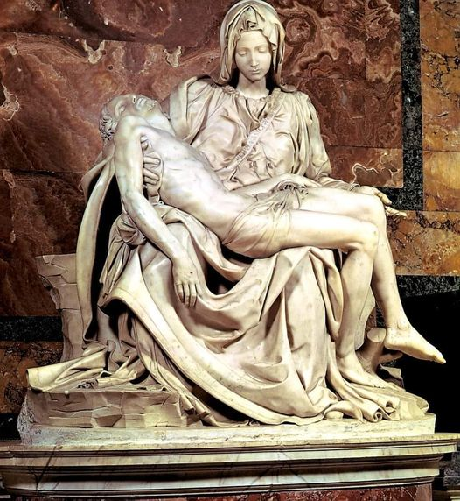

Death could not erase the fact that he was her child and she was still mothering him.

The grave and the womb both offer rich soil from which love can grow. I’m not sure I’ve ever loved my mum more than I have now since she died. I remember moments with much more clarity and tenderness than I did before. I feel more curious now about who she was as a girl and as a woman, not just as my mother. I am more appreciative of all the things she did that made me feel safe, special and beloved. Sometimes I almost feel her inside of me, changing me in small ways. Here’s an example: I could never really float before, my feet sank. But my mum was incredibly buoyant. She was an excellent floater. And she loved it. Strangely enough, I have noticed that, since she died, I float more easily than I did before, and I enjoy it more.

She was with me when my babies were born and said afterwards “that was just pure love.” My mum always enjoyed feeding people, especially her kids. There’s a photo of her feeding me as I nurse Lila 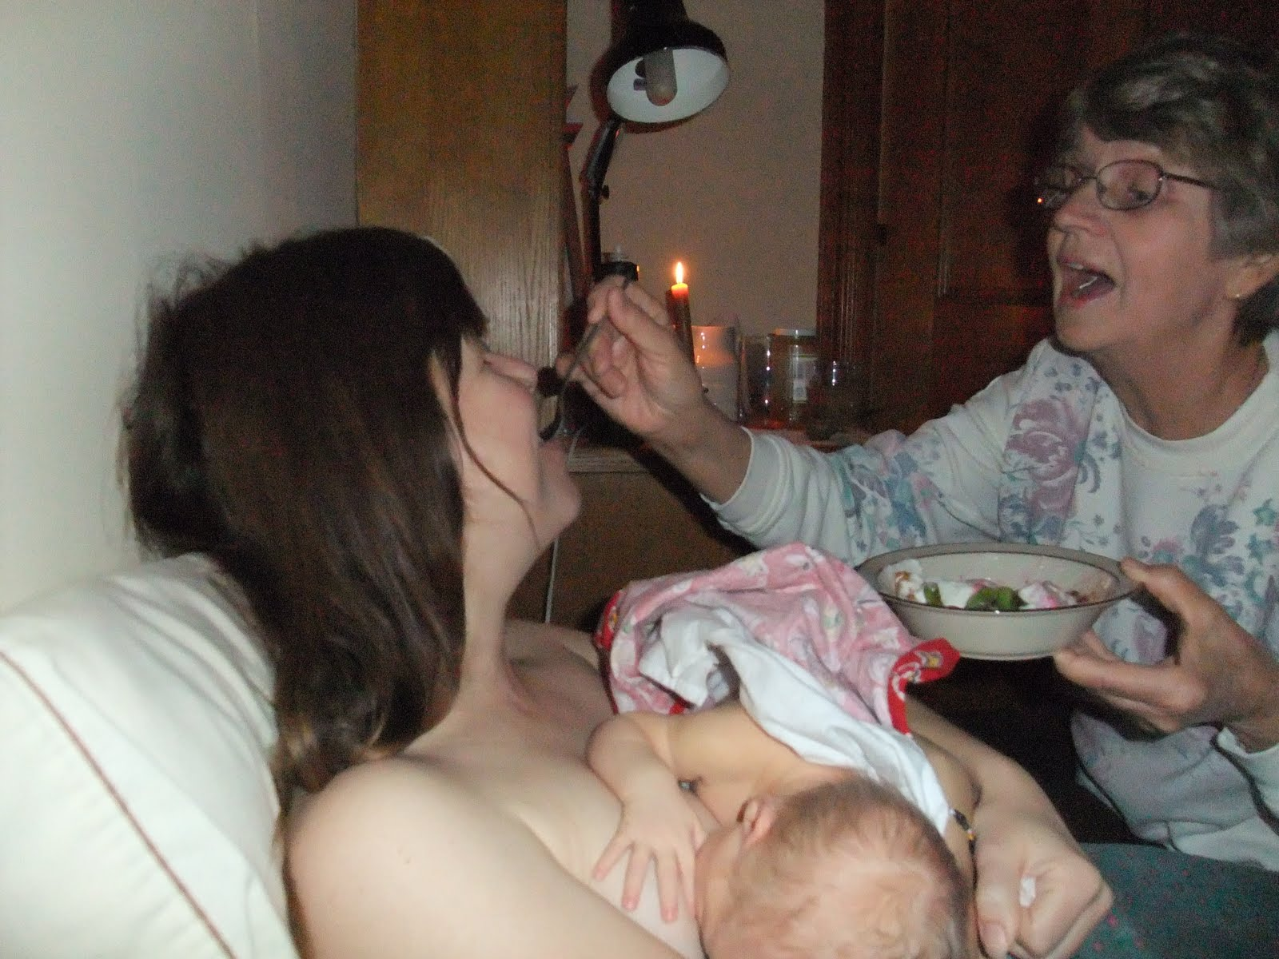

And she is still somehow feeding me as I cook for my family and feed my dog.

A phrase that is heard frequently nowadays is intergenerational trauma. It’s not a new idea though. In the bible (particularly the Old Testament) there is talk of the wrong-doings or hateful actions of a people being passed down from generation to generation. Acts of love and compassion can also be passed down, interrupting the patterns that perpetuate harm. My parents chose to parent in a way that broke the pattern of abuse and neglect that they had experienced as children.

How did Elizabeth know Mary was pregnant when she came to visit? She wouldn’t have been showing much yet.

Before Joel and I were dating, I had a strange moment where I looked at him, he was standing on the front porch of the house where he was living at the time wearing a plaid shirt and talking to someone and, just for a moment, it felt like we had been married for a long time. I think love does things like that, it travels through time and plays with us.

When I was a child I decided I would be a spinster. Now, because of love’s strange way of interrupting plans and messing with self-concept, I am a wife and mother. I also took a test in high school that told me I would enjoy preaching. I laughed. And yet here I am.

When I was younger I was also scornful of traditions. Why do the same boring old things over and over? Couldn’t you find a better recipe? The same Christmas cake? The same date pinwheel cookies? Why advent? Why pretend Jesus hasn’t been born yet? Again. Only now do I see the value in traditions, how they tie us to the past, ground us, keep us connected. Memories of what has been enhance the flavour of what is. We can tell the stories of Christmases long ago even as we smile at “Baby’s First Christmas” or face our first Christmas alone. We live on stories, feed on them. They help us make sense of things, be less fearful of life passages. We’re here right now because of stories that were recorded in the Bible. Mary celebrates a terrifying outside-of-marriage pregnancy in a culture and day and age where such occurences were punishable by death. But, instead of panicking, she celebrates, identifies with and draws strength from stories about her ancestors: women celebrated in oral tradition, women to whom God promised children, like Hanna who bore the prophet Samuel. Mary sings a song that echoes Hanna’s song of thanksgiving.

Thanksgiving. Reading the song and considering the context reminds me of the way Jonah said thank you while still in the belly of the whale. Had all of what she was describing transpired already? If so there would be no need for a saviour. Yet she uses the past tense. Gratitude here is not for what already is but for what will come. In a way, both of these women are prophets. I was taught never to end an ask message with a thank you because it’s too presumptuous. But it is perfectly appropriate to end or even begin our prayers of petition with a thank you. In moments of spirit-inspired vision or wisdom, the reality of that future is fully-formed and apparent, if not in our minds, then in our hearts. The content of Mary’s Magnificat, the vindication of love, and the full manifestation of God’s kingdom on earth not only will be but are already here, just unseen yet, unborn. So even in our grief, even in the despair of being in the belly of a whale, we can celebrate and give thanks without denying our present reality. It is all true. It is all now.

I think, in the day-to-day context, we need to insist on experiencing time as linear, simply because the alternative is just too confusing. But when we put on our Holy Ghost glasses we are able to embrace all of the bizarre and paradoxical realities that, unless we happen to be quantum physicists, our workaday world simply cannot accommodate. Here, during Advent and Christmas, we can know that Jesus is celebrating his own birth with us and is waiting with us to be born. And we, like Mary, are forever pregnant with the numinous mystery of now and not yet but soon…

There are a couple of ways I tend to experience life and there’s one word for both of them. Relentless. The first is a kind of exhausted overwhelm laced with anxiety. I can’t… or no not this too! Then a gentle voice reminds me that yes you can and you have already and you’re not doing it anyway, mostly it’s being done around and despite you and your worrying. If I listen, and then listen just a little bit more I experience a different kind of relentless: relentless bring-you-to-your-knees-weeping-with-gratitude grace and love. I normally favour the first, even though I know the second is equally, or even more, true. Richard Rohr makes sense of this (frustrating) reality when he describes love as “the attraction of all things towards all things” or a “universal language and underlying energy” and also explains that “to move beyond our small-minded uniformity, we have to extend outward, which our egos always find a threat, because it means giving up our separation, superiority and control.” (*The Universal Christ* p. 70) In other words, to become utterly dependent on Love, like a child in a womb.

When I first experienced myself to be pregnant I walked differently, carefully. How does our divine parent walk, knowing they carry the whole universe inside them? Carefully. Lovingly. And we can trust they will not trip or fall. Even when we kick out and complain or throw the kind of tantrums that lead to mass destruction. Our Parent can absorb all of that and more.

The thing with love is that it’s so easy to downplay or mistrust. It’s too simple, too straightforward. Parental love is kind of embarrassing. Romantic love or eros is too often confused with lust. The love of God is unimaginable most of the time. According to Richard Rohr, “The only thing that separates you from God is the thought that you are separate from love.” (p.80)

Living in love means relinquishing control and that challenges our ego. Fear, guilt, cynicism and anger can often confuse us and keep us from resting in it, choosing it, moment by moment, day by day. Love often means doing that thing we fear but know is necessary. It feels nearly impossible and utterly unattractive until we are engaged in it, committed to it, in it.

I think the weirdest thing about Christianity is that following its precepts never promises that things will go well for you. In fact, the precise opposite is true. Jesus says pick up your cross and follow me. He promises pain, suffering, humiliation, poverty, homelessness, torture, death. So why would people go for that? He talks about a yoke and then he talks about it being light or gentle. The thing is, you can either live from love or from fear. If you lose the fear, it’s all love. And then it’s freedom, pure freedom. There are two ways to walk in the rain: you can hunch over, clench your muscles and hate every moment of it and get wet. Or you can stand comfortably, walk normally, relax, and get wet. Imagine what a person without fear would walk like, what a person governed only by love would talk like. This is a new mantra I have been using lately: “what would love do right now?” It kind of dances with my continuous question: “Is God here?” And the answer is always the same: yes, God is here–in you and surrounding you. Listen. Trust. Love.